**Valley Primary School**

**GROWING AND LEARNING TOGETHER TO BE THE BEST WE CAN BE !**

**ASPIRE…ENJOY…ACHIEVE…CHALLENGE !**



**Head Teacher: Miss S. Milewski**

[**office@valley.solihull.sch.uk**](mailto:office@valley.solihull.sch.uk) **Tel: 0121 743 4691**

**Old Lode Lane, Solihull, B92 8LW (KS2 site). Fallowfield Road, Solihull, B92 9HQ (EYFS and KS1 site).**

Collins Adapt has been introduced to enable children to reinforce the learning accessed in class over the week and to share this with parents. For children in Years 2 to 6, homework will be set each Monday and must be completed by the following Monday. For children in Year 1, this Maths homework is optional. Your child will now have been shown how to access Collins in school. However, we hope that the guidance attached from Collins will be helpful. If you have any questions regards log in details or access, please contact your child’s class teacher as we are keen to support.

Adapt Primary Maths – Parent Guide

# Logging in

Your child has been set up with access to Adapt Primary Maths from Collins. They will need to access Adapt via username and password

* + Go directly to the login page [https://pupil.collinsadapt.co.uk](https://pupil.collinsadapt.co.uk/) and use the details provided by your child’s class teacher to access Adapt.

# Pupil dashboard

When your child first logs in, they will land on the pupil dashboard, shown below. Any tasks assigned to them by their teacher will appear under “My Tasks” (in this case “Money 4”).

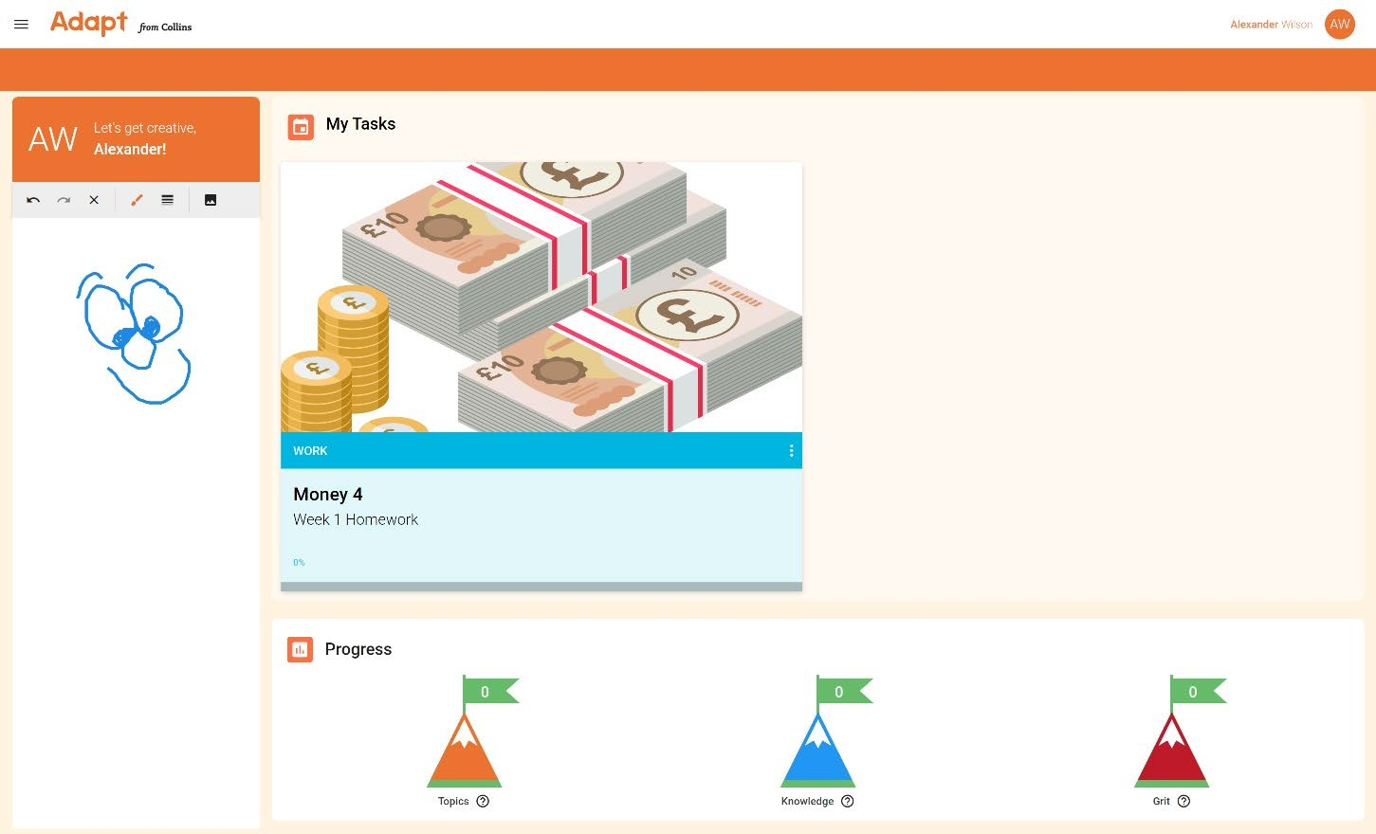

# Completing tasks

Clicking on a card from the dashboard will launch the task. The first page your child sees will be a summary of the task.

After the summary screen, a question will be displayed. For every question in Adapt, the learner is required to give both their answer and their confidence level (“I know it”, “Think so”, “Not sure”, No idea”) by selecting one of the owl icons. Both the answer and the confidence level will determine what the learner sees next, with each learner’s journey through the task unique to them.

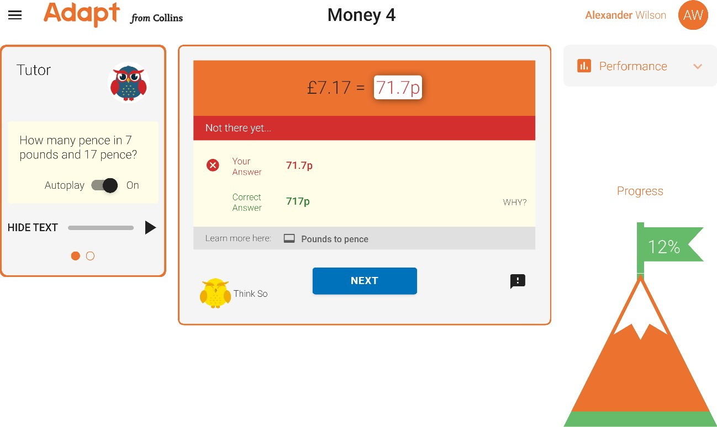

After submitting any answer, the learner can select “Learn more here” to find out more about the topic. After getting an answer wrong, they can select “WHY?” to find out why it was wrong.

As well as questions, learners will also see explainers for each topic they encounter. Once they have read (or listened to) the explainer, they will need to select their confidence level for the topic.

